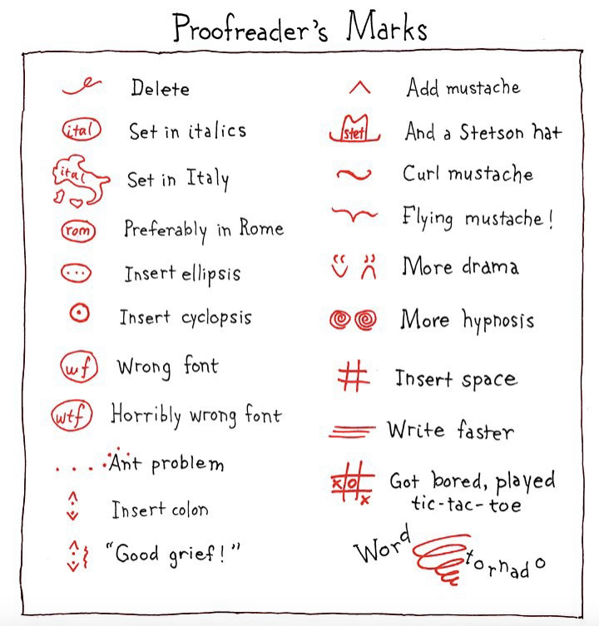**Saint Xavier University**

**Fall 2022**

ENGL 353-01   
Writing: The Editing Process

**Fall 2022**

**T/Th 2:00 p.m. - 3:20 p.m., WAC L331**

**Instructor information**

**Dr. K. Kaiser Lee** (*she/her/hers)*

**Campus office hours, Fall 2022:**Mondays 10:55 AM - 11:55AM   
beginning Sept. 12.

**Office location:** WAC N-429   
(Take the elevator near the campus post office to the 4th floor; take a right out of the elevator and turn right at the hallway next to the kitchen; my office is at the end of that hall.)

**Email:** [kaiserlee@sxu.edu](mailto:kaiserlee@sxu.edu) (best way to reach me).

**Office phone:** 773-298-3230

**Text me or leave voice mail:** 224-764-0319

This version of our syllabus has been damaged by 35 errors deliberately inserted into it and there are at least two issues that should be raised with the author. there are probably more that your instructor isn’t aware of! In-class exercise 1: Find the errors.

*This is a hybrid course. After the first four weeks or so we will meet face-to-face once and do online work instead of meeting a second time. See the course calendar in this document for details.*

**ENGL 353 course catalog description**

“Pre-requisite: P (RQ) ENGL-120. This course is an introductory proofreading/copyediting course that presents an overview of the editorial process and instruction on the basic tools and tasks of proofreaders and copyeditors. Students will use style manuals and reference books, create style sheets, and learn methods of querying authors and project editors.”

**Goals for the semester**

We will learn how to:

* Edit your own writing.
* Edit the writing of others.
* Develop good editing habits (use of dictionary and usage dictionary, for example).
* Use and create a style guide.
* Edit accurately – not only for grammar and usage, but also for facts, content, and consistency.
* Working as a professional editor familiar with all levels of editing (proofreading, copy-editing, substantive editing, and global editing).
* Collaborate on producing a publication to get practice writing, editing, and doing basic document design using open source programs like [Libre Office](https://www.libreoffice.org/) and [Scribus](https://www.scribus.net/).

**Required & recommended texts & supplies**

Biel, Joe. *Make a Zine!* *Start Your Own Underground Publishing Revolution,* 4th edition. Microcosm Publishing.

Einsohn, Amy and Schwartz, Marilyn. *Copyeditor's Handbook and Workbook.* University of California Press. The class calendar indicates sessions you will need to bring these books with you.

**Recommended:**

*Chicago Manual of Style.* The University of Chicago Press.

Garner, Bryan A. *The Chicago Guide to Grammar, Usage, and Punctuation.* The University of Chicago Press.

*“A good dictionary and usage dictionary are strongly recommended. You’re insane if you don’t own these already.” - David Foster Wallace*

**Supplies**

Laptop for in-class work.

$5.00 or so to print copies of the Zine project.

**This syllabus is our blueprint for this semester. As the semester progresses, changes may become necessary. These changes will be announced in class, on Canvas, and via email.**

**Teaching /Learning Methods**

• Direct instruction on the editing process.

• Readings, exercises, and other forms of instruction on grammar, usage, and other topics relevant to the editing process.

• Group projects to teach collaboration and provide a basic introduction to the publishing process

• Detailed readings on issues related to editing that are discussed in class sessions and discussion boards.

**Instructional Uses of Technology**

The content, delivery and assessment of this course is supported by the use of the following academic technologies:

* Presents for the class will be created in Keynote or Libre Office and accessible on Canvas.
* Canvas Learning Management System for assignments, tests, grades, discussion boards, and similar class activities, as well as assigned readings.
* Productivity tools such as Microsoft Word, Google Docs, or Libre Office, whatever word processing software you like to use, are available for students to complete their assignments.

**Assignments, Projects, Course Work**

**Course discussion boards** 10 points

**In-class exercises** 10 points

**Editing Test**  18 points

**Editing Projects** 10 points

**Wikipedia Editing Project**  23 points

**Zine project** 25 points

**total available: 100 points**

**Grading scale**

There are no more than 100 points available points from the semester’s work. At the end of the semester the total number of points earned will translate into the following grades:

90–100 points: A   
80–89 points: B   
70–79 points: C   
60–69 points: D  
59 points or less: F

Any final grade decimal numbers from .5 to .9 will be rounded up to the next whole number. Decimal numbers from .1 to .4 will remain at that whole number. For example, 89.2 would be a B; a grade of 89.6 would be an A.

Grades for projects are calculated on the same scale. For example, on a project worth 20 points, a solid B project (good – see below) would earn 17 points (85% of 20), while a very good project (not quite excellent) would earn 17.8 points (89% of 20).

**Evaluation criteria**

The following general evaluation criteria will be used to evaluate the assigned writing in this class. assignment descriptions may include additional expectations. These criteria should give you an indication of expectations for an undergraduate editing course:

A work – outstanding; free of all grammatical errors; closely follows concepts discussed in class for the level of editing the assignment calls for.

B work – very good; may contain one or two grammatical errors; overlooks one concept for the level of editing the assignment calls for.

C work – errors in grammar / spelling / mechanics / tone / word choice remain in the document: uses a different level of editing than what the assignment calls for.

D work – significant errors in grammar / spelling / mechanics / tone / word choice remain in the document; does not take assignment seriously; does not adhere to editing practices.

F work – plagiarized or not submitted.

**To Pass This Class**

**To be eligible to pass the course, you must (1) complete and submit all major projects, including drafts of each project, when assigned (2) engage in class activities on a regular basis, and (3) meet the minimum attendance requirements as described in this syllabus.**

**Due dates, grace periods and late work policy**   
This class has a “grace period” for most assignments. for a note on each assignment indicating if the grace period does or does not apply.   
  
*The due date* is the day that your work is due.   
  
*The grace period* occurs between the due date and the deadline. Work submitted during the grace period will be marked as *late* in Canvas; however, there is no grade penalty for work submitted during the grace period.  
  
*The deadline* comes two days after the due date and is the final moment that Canvas will be open to accept a project. If you cannot not turn in your work by the end of the grace period, you will need to contact me and see if alternate deadlines may be arranged; such requests will be considered on a case-by-case basis.

**More about technology in our lass**

* Please bring your laptop to class meetings; the Course Calendar indicates when you need to bring *The Copyeditor’s Workbook*.
* Smart phone policy: Treat it as you would in any professional setting – its okay to glance at it, its okay to use it as an educational tool (look up a fact relevant to class discussion or use it to refer to your e-textbook); its not okay to answer a call or concentrate on it exclusively during class. Silent mode during class, please.
* Reliable technology is crucial to your success in school. Be proactive and get help if you experience connectivity or other technology issues, For general technological assistance, visit <https://sxu.teamdynamix.com/TDClient/2022/Portal/Home/> .
* Assignments are submitted via Canvas, SXU's course management system. **If a submitted file will not open, or is otherwise corrupted, the work will be counted as not turned in.**
* If you haven't already, you should develop a data saving and backup plan with redundancy – for example, saving your work on *both* a USB drive and a clout-based system (Dropbox, Google Drive, iCloud) in addition to saving work on your device.
* Consider devising a standardized method of naming your files, one that identifies the course and the assignment while avoiding punctuation or spaces (for example, ENGL353-essay.docx, not essaydraft.docx.)

**Attendance**

Plan on attending every class session. You may miss up to three class sessions with no penalty. There are no excused vs. unexcused absenses; three should be enough for most SXU-related absenses (athletics, field trips) as well as religious holidays that aren’t a part of the SXU calendar.

**Missing more than four sessions is grounds for failing the course.** Please refer to the section “Learning During Stressful Times” and contract me if you’re having trouble with attendance.

**When you have to miss a class session**

You don’t have to tell me that you missed class, or why you were absent. If you miss a class – after reading through the course Canvas site, if you have specific questions related to what we did in class, please email me those questions. I will likely not answer emails that only tell me you missed a class, or ask the too-general and poorly worded question, “Did you do anything important while I was absent?”



**Course Evaluations (SEIs)**

At the end of the term you will receive an email asking you to submit an evaluation of the course from [courseevaluations@sxu.edu](mailto:courseevaluations@sxu.edu). You’re input is very important to the University, the department, and to me. I take your comments seriously, and I use them to improve the course the next time I teach it. Please help me by filling out the evaluation; your thoughtful feedback will help students who enroll in the course in the coming semesters.

**Plagiarism and Academic Honesty**  
Students are expected to adhere to the Saint Xavier University Academic Honesty Policy. Representing writing done by someone else as your own work should never be an option. Plagiarism has cost the jobs, not to mention the reputations, of business leaders, politicians, and university presidents. At the end of this document you will find additional information from the University and the Department of Languages and Literature on plagiarism.

**Writing Assistance: SXU Learning Center**

The SXU Learning Center, located in L110, provides resources for undergraduate and graduate students. Subject tutors are available to help improve your studying skills, go over study guides, and practice exams. Subject tutoring is by appointment only and can be accessed via the portal under “Tutoring and Writing Sign-up.” The Learning Center also provides writing consultants that excel at helping students think about the development of ideas, the arguments of an essay, grammar, punctuation, and documentation. Writing consultants are available by appointment or walk-in. If you would like after hours or a supplement to face-to-face services, you can access the Smarthinking Online Tutoring via Canvas. For questions or to make an appointment stop by L110 or call (773)298-5148. Appointments can also be made at [https://sxu.mywconline.com](https://sxu.mywconline.com/) .

For more information visit [www.sxu.edu/academics/resources/learning-center](http://www.sxu.edu/academics/resources/learning-center) .

**The Center for Accessibility Resources at SXU**

If you believe that you need accommodations for a disability please contact the Center for Accessibility Resources (CAR) in L-108 or call 773-298-3308 to discuss your needs and the process for requesting accommodations because CAR is responsible for coordinating disability-related accommodations and will issue students with documented disabilities "Confidential Accommodation Plan" letters, as appropriate. Since accommodations may require early planning and generally are not provided retroactively, please contact CAR as soon as possible.

**Saint Xavier University Mission Statement**

Saint Xavier University, a Catholic institution inspired by the heritage of the Sisters of Mercy, educates persons to search for truth, to think critically, to communicate effectively, and to serve wisely and compassionately in support of human dignity and the common good.

**Learning during stressful times**

We’re all copping with this stressful environment as best as we can; COVID-19, political upheaval, dramatic climate events, the constant onslaught of social media, and more are contributing to an environment that makes it tough to learn.

If you need extra help, or if you need more time with something, or if you feel like you’re behind or not understanding something, please do not suffer in silence – talk to me! I will work with you. If you tell me you’re having trouble, I will not judge you or think less of you. You donut own me an explanation or personal information about your life. All the ways to contact me are listed at the top of this syllabus. (Please keep in mind that faculty are experiencing the same environment that you are, so I may need you to extend me the same courtsey!)

**Campus COVID-19 Concerns**

If you need learning acommodations, or if you have questions about anything related to how SXU is responding to the pandemic, please visit <https://www.sxu.edu/covid-19/return-campus.aspx>

**Basic needs security**

If you have difficulty affording groceries or accessing sufficient food to eat everyday, or if you lack a safe and stable place to live, and you believe this may effect your performance in this course, please contact the [Dean of Students](https://www.sxu.edu/dean-students/) for assistance. You can also talk to me if you are comfortable in doing so. I’ll do my best to locate additional resources if possible.

**SXU Counseling Center**

The mission of the Counseling Center is to guide students toward personal [wellness, balance and growth](http://sxu.edu/student-life/counseling/wellness-balance-growth.asp). Licensed counselors facilitate this through personal counseling and wellness education. The Counseling Center is open from 8:30 a.m. to 4:30 p.m. Monday thru Friday. And is located at 3911 W. 103rd Street in the Driehaus Center. To learn more and to schedule an appointment, visit [the Center’s web page](https://www.sxu.edu/student-life/counseling/index.asp). In case of emergency during office hours call 773-298-4045, or come by the Counseling Center. Outside office hours: If the emergency is on campus, call Public Safety at 773-298-3911, and they will contact the on-call counselor. If the emergency is off campus, call 911.

**Center for Accessibility Resources**

If you believe that you need accommodations for a disability, please contact the Center for Accessibility Resources (CAR) in L-108 or call 773-298-3308 to discuss your needs and the process for requesting accommodations. CAR is responsible for coordinating disability-related accommodations and will issue students with documented disabilities “Confidential Accommodation Plan” letters, as appropriate. Since accommodations may require early planning and generally are not provided retroactively, please contact CAR as soon as possible.